Issues found in Angadi
7 October 2026
I checked angadi.net. Went through vendor signup and the dashboard. Landing page UI is good, sleek and clean. But that is not maintened inside the application. Most of the pages are still raw HTML. Need to re write them in React. Issues I faced are below, in the same order.

OTP time limit
For login and signup, OTP time is only 30 seconds. This is very less. By the time we open the message and come back, the code is already gone. Kindly increase the time for login and signup both. I dont have a screenshot for this one.

Go offline and go online
In the dashboard, if we click Go offline or Go online, the entire page is reloading. It should not reload the full page. Only the status should change. I was scrolled down and it sent me back to the top.
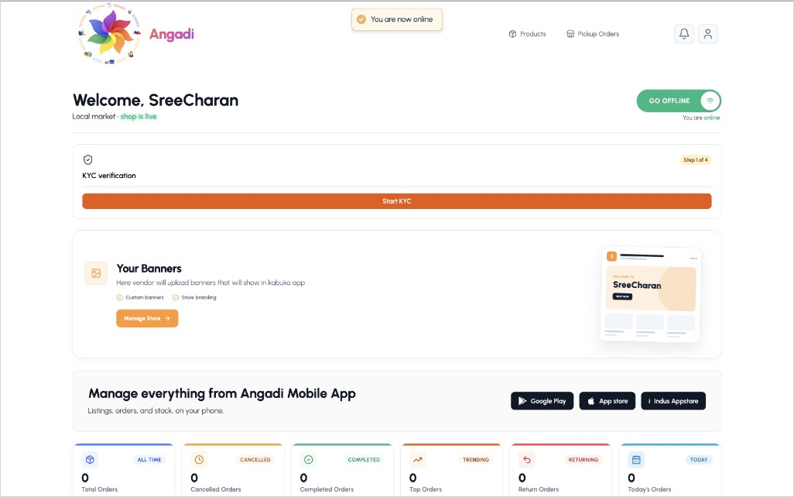
Go offline button is on the right side. On clicking this, full page gets reloaded.

Free coupon
Before dashboard, vendor subscription is compulsory. Free plan is asking for a free coupon. There is one more field for marketing team coupon wich is optional. I entered a code and it showed Invalid coupon code. Nowhere it is written from where we will get the free coupon. Please mention that below the free coupon field.
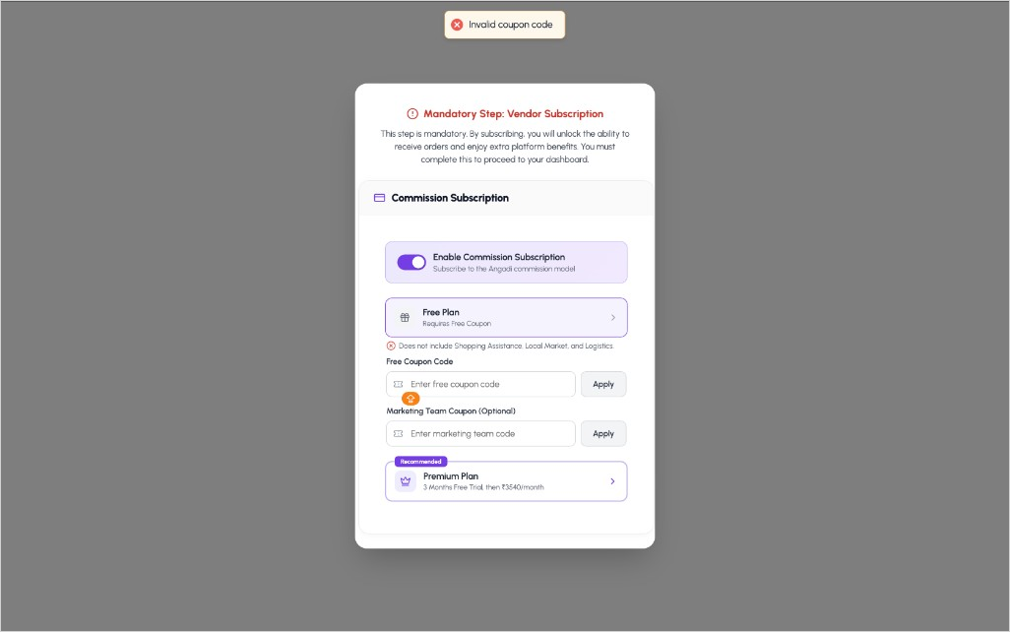
Subscription step. Coupon came as invalid, and it is not told where to get the free coupon.

Email verfication
In the identity step there is email adress and a Verify button. I verified the email, went to the next step, and came back. Again it is asking to verify the same email. Next button is also disabled, and it shows please correct the errors highlighted above before proceeding. This happend many times whenever I came back from the later step. Once the email is verified, it should not ask again.
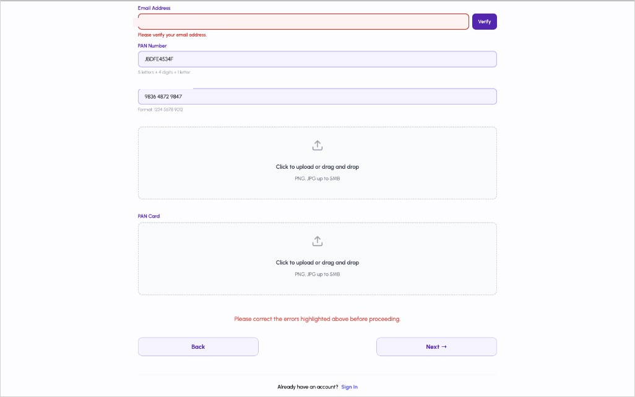
Came back to this step and again email verfication is asked. Adress, PAN and Aadhaar I have covered.

Digilocker
Same form is asking PAN number, Aadhaar number, and upload of both cards. Digilocker verfication is happening only after login. In the dashboard also, KYC is still showing as step 1 of 4 with Start KYC button. Digilocker should be done here itself, before login. Upload can stay if digilocker is not working. Dont ask for the same documents again after login.
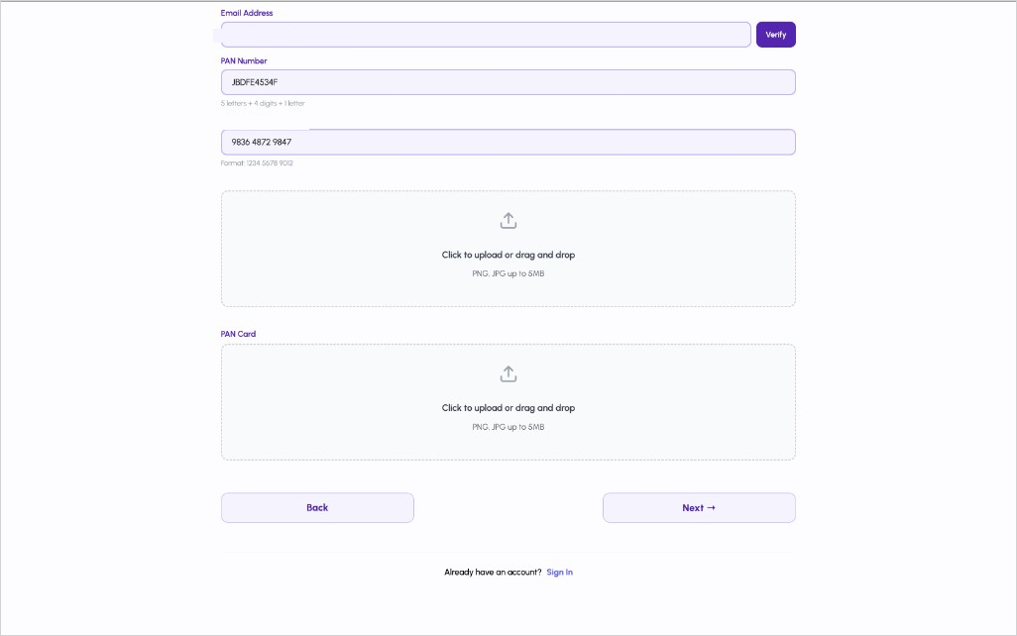
This is the signup form. Digilocker should be here itself, not after login. Adress, PAN and Aadhaar are covered.

Store activation code
In the business page, store activation code is requied to go live. It is not mentioned what is the lenght of the code. I entered a very long string and it went outside the box. Please set one definate lenght, show it under the field like how PAN is showing 5 letters + 4 digits + 1 letter, and dont allow more than that.
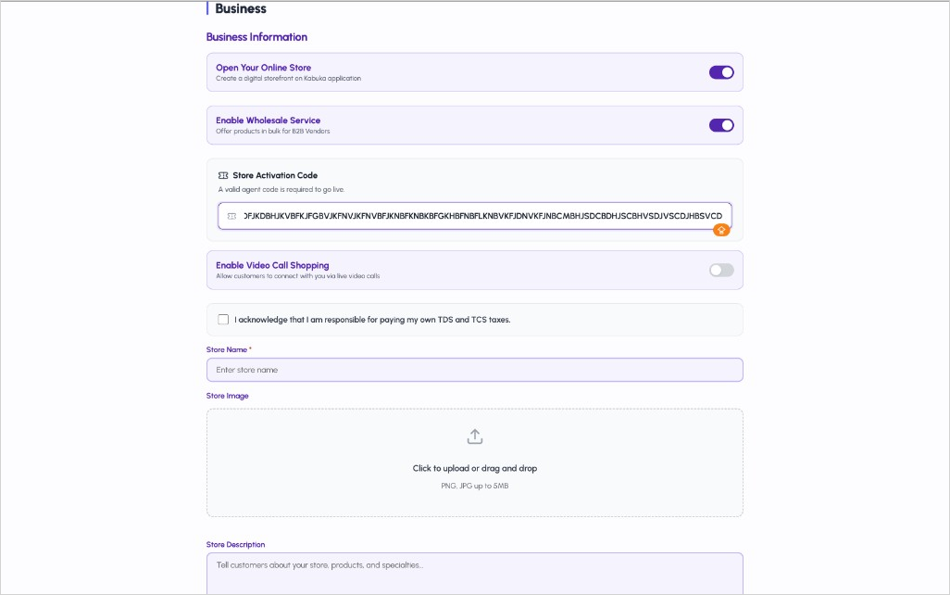
Activation code has no fixed lenght, so this long string is going outside the box.

Inside pages
Landing page I will not change. It is already good. Inside pages are not matching with it. Dashboard, subscription popup, identity form and business form are looking like raw HTML. Spacing and buttons are different in every screen. These pages need to be re writen in React, using the same components as the landing page.

